West Virginia Reading Association
WV AUTHORS FORM

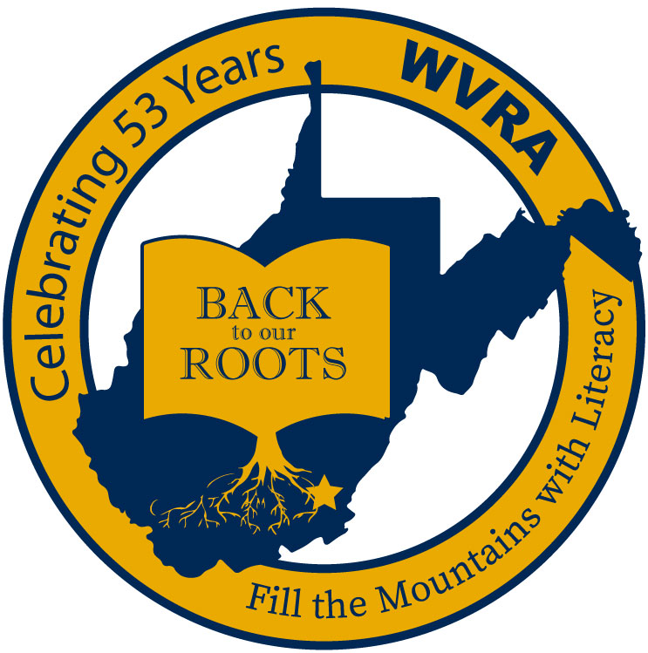

Dear West Virginia Authors:
WVRA is the oldest professional organization dedicated to eradicating illiteracy in the Mountain State. The conference, theme entitled Back to Our Roots, is at the Greenbrier Resort in White Sulphur Springs on November 18-19, 2021.
WVRA is delighted to invite WV Authors to once again attend the conference at a special reduced rate, of $40. This is a $60 discount off the regular preregistration fee.
Please complete and return this special registration form especially for WV authors along with full payment on or before October 16, 2021 in order to receive this reduced rate. With this rate authors will receive space at a table in the Author Interactive area currently located in the Exhibit Hall.
There will be special luncheons available each day at the rate of $45. Authors may register for these luncheons on the attached registration form to purchase tickets.
Lodging is the responsibility of the authors. A special rate is available from the Greenbrier. The form may be obtained at wvreading.com, under Conference 2021.
If you would prefer to be in the exhibit area of the Exhibit Hall, those registration forms are available online at wvreading.com and those tables are available for $250.
While at the table, authors may sell and sign as many books as they wish. Please note that all materials should fit on a standard size table and should not interfere with other authors.
Attendees enjoy visiting with authors and purchasing autographed copies of their books during the conference. We hope that this will enable authors to network with conferees and other authors. WVRA looks forward to seeing you in November.
Authors wishing to present concurrent sessions or workshops during the conference, must complete and have accepted for presentation a proposal on the 2021 Call for Proposal form on the wvreading.com website and must pay to register as a WV Author.

WV Authors Registration Form

NAME: ____________________________________________________________________________
(As it is to appear in the conference program)

Mailing Address: ____________________________________________________________________

City: ________________________________; State: ________; Zip Code: _______________

E-Mail Address: ___________________________
Preferred Telephone Number: (_____) ____________; I can receive texts at this number __ yes __ no.

Best times to contact me, only if necessary______________________________________.

______ Number of tables at $40 each. Enclosed is my payment of $_______ for the table(s).
Online registration will be available for credit card payments at $50 per table at: regonline.com

______ I would like to purchase a luncheon ticket for Thursday, November 18, 2021, for $45.

Enclosed is my payment of $______ for the luncheon ticket.

______ I would like to purchase a luncheon ticket for Friday, November 19, 2021, for $45.

Enclosed is my payment of $______ for the luncheon ticket.

Please indicate below, the times you plan to attend the conference. This will allow the conference committee to be sure there is enough tables for all the authors.
Thursday, November 18, 2021: _________________AM __________________ PM
Friday, November 19, 2021: _______________ AM ___________________ PM

Please return this form by either mail or e-mail, on or before October 16, 2021 to

WVRA Author Registration, Aleda Hileman
PO Box 382
Craigsville, WV 26205

